Lesson 9: Multiplying Polynomials
Classwork
Exercise 1
  - Gisella computed $342×23$ as follows:

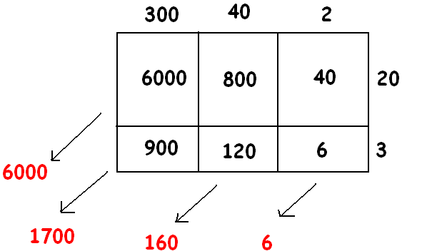

Can you explain what she is doing? What is her final answer?

Use a geometric diagram to compute the following products:
$a. (x+2)(x-4)$ $b. \left(2x^{2}+10x+1\right)\left(x+1\right) c. (x-1)(x^{3}+6x^{2}-5)$

Exercise 2
The expression $10x^{2}+6x^{3}$ is the result of applying the distributive property to the expression
$2x^{2}(5+3x)$. It is also the result of the applying the distributive property to
$2(5x^{2}+3x^{3})$ or to
$x(10x+6x^{2})$, for example!
For (i) to (vi) below, write down an expression such that if you applied the distributive property (undistributed) to your expression it will give the result presented. Give interesting answers!
$i. 6a+14a^{2}$ ii. $2x^{4}+2x^{5}+2x^{10}$ iii. $6z^{2}-15z$

$iv. 42w^{3}-14w+77w^{5}$ v. $z^{2}\left(a+b\right)+z^{3}(a+b)$ vi. $\left(2z+10\right)\left(z-2\right)-(6z-14)(z-2)$

Exercise 3
Sammy wrote a polynomial using only one variable, $x$, of degree 3. Myisha wrote a polynomial in the same variable of degree 5. What can you say about the degree of the product of Sammy and Myisha’s polynomials?

Extension
Find a polynomial that, when multiplied by $2x^{2}+3x+1$, gives the answer $2x^{3}+x^{2}-2x-1$.

Problem Set

- Use the distributive property to write each of the following expressions as the sum of monomials.

  - $3a(4+a)$ b. $\frac{1}{3}(12z+18z^{2})$

$c. 4x(x^{3}-10)$ d. $(x-4)(x+5)$

$e. (2z-1)(3z^{2}+1)$ f. $(10w-1)(10w+1)$

$g. \left(-5w-3\right)w^{2}$ $h. (20f^{10}-10f^{5})÷5$

$i. (x^{2}-x+1)(x-1)$ $j. (-2f^{3}-2f+1)(f^{2}-f+2)$

2. Use the distributive property (and your wits!) to write each of the following expressions as a sum of monomials. If the resulting polynomial is in one variable, write the polynomial in standard form.

a. ${\left(a+1\right)}^{2}$ | b. ${\left(p+q\right)}^{2}$ | c. ${\left(z-3\right)}^{2}$

3. Use the distributive property to write each of the following expressions as a polynomial in standard form.
$a. (s^{2}+4)(s-1)$ b. $3(s^{2}+4)(s-1)$ c. $(u-1)(u^{5}+u^{4}+u^{3}+u^{2}+u+1)$

